|  |
| --- |
| E:\Harshala Wadkar\2020-21\MMCC logo updated.png  MARATHWADA MITRA MANDAL’S  **COLLEGE OF COMMERCE**  A  PROJECT REPORT ON  **Sheraton Grand Hotel**  Submitted in partial fulfillment of the requirements  For the award of the Degree of  **BACHELOR OF BUSINESS ADMINISTRATION (COMPUTER APPLICATIONS)**  under Guidance of  **Prof. Vishakha Wagh**  Submitted by:  **Alok Santosh Agarwal**  **Satvik Sharad Durge**  **SAVITRIBAI PHULE PUNE UNIVERSITY**  **In the academic year (2024-2025)** |

MARATHWADA MITRA MANDAL’S

**COLLEGE OF COMMERCE**

Affiliated to Savitribai Phule Pune University, Re-Accredited by NAAC with “A” Grade

ISO 9001:2015 Certified, Awarded as Best College by Savitribai Phule Pune University

202/A, Deccan Gymkhana, Pune – 411004

[principal@mmcc.edu.in](mailto:principal@mmcc.edu.in), [enquiry@mmcc.edu.in](mailto:enquiry@mmcc.edu.in), [www.mmcc.edu.in](http://www.mmcc.edu.in/)

|  |
| --- |
| CERTIFICATE  (TO WHOMSOEVER IT MAY CONCERN)  This is to certify that the following students  **Alok Santosh Agarwal**  **Satvik Sharad Durge**  Have completed the project entitled  **Sheraton Grand Hotel**  In a particular fulfillment for the award of  **BACHELOR OF BUSINESS ADMINISTRATION (COMPUTER APPLICATIONS)**  UNIVERSITY OF PUNE  In the academic year 2024-2025  This work has been carried out by then under my supervision and Guidance  **Prof. Vishakha Wagh**  Submitted by:  **Alok Santosh Agarwal**  **Satvik Sharad Durge**  Prof. Vishakha Wagh Prof.Nidhi Satavalekar Dr.Ganesh Patare  (Guide) (HOD) (Principal)(I/C) External Examiner  **ACKNOWLEDGEMENT**  We would like to express our deepest and most sincere gratitude to all the individuals and institutions who have supported us throughout the development of our project “**Sheraton Grand Hotel** ”.  We are especially thankful to our project guide **Prof. Vishakha Wagh**, whose expert guidance, constructive feedback, and unwavering encouragement have played a pivotal role in shaping our project. Her exceptional leadership, vast knowledge, and insightful suggestions have not only enhanced our technical skills but have also inspired us to strive for excellence.  We are also deeply indebted to our Head of Department **Prof. Nidhi Satavlekar**, for her guidance, support, and recommendations. We would also like to express our sincere appreciation to our Principal **Dr. Ganesh Patare**, for providing us with the necessary resources, infrastructure, and support to complete our project.  Furthermore, we would like to thank our college for providing us with the necessary facilities, support, and encouragement to complete our project. We appreciate the support and guidance provided by the college administration, which have enabled us to successfully complete and implement our project. |

**INDEX**

|  |  |  |
| --- | --- | --- |
| SR.NO | PARTICULARS | PAGE NO |
| 1 | INTRODUCTION |  |
|  | INTRODUCTION TO SYSTEM | 5 |
|  | SCOPE OF SYSTEM | 6 |
|  | PROPOSED SYSTEM | 7 |
| 2 | SYSTEM ANALYSIS |  |
|  | FACT FINDING TECHNIQUE | 8 |
|  | FEASIBILITY STUDY | 8 |
|  | HARDWARE REQUIREMENTS | 8 |
|  | SOFTWARE REQUIREMENTS | 9 |
| 3 | SYSTEM DESIGN |  |
|  | E-R DIAGRAM | 10 |
|  | CONTEXT LEVEL DIAGRAM | 11 |
|  | DATA FLOW DIAGRAM | 13 |
|  | FILE DESIGN | 15 |
|  | DATA DICTIONARY | 16 |
| 4 | FORM DESIGNING (SCREEN SHOTS) | 17 |
| 5 | REPORTS | 18 |
| 6 | LIMITATIONS | 19 |
| 7 | ADVANTAGES AND DISADVANTAGES | 20 |
| 8 | FUTURE ENHANCEMENT | 22 |
| 9 | BIBLOGRAPHY | 23 |

1. **INTRODUCTION**

**1.1 INTRODUCTION TO SYSTEM**

**Welcome to Sheraton Grand Hotel – Where Luxury Meets Comfort**

Nestled in the heart of the city, **Sheraton Grand Hotel** offers a seamless blend of modern luxury and warm hospitality. Whether you are here for business, leisure, or a special occasion, our world-class amenities, elegant accommodations, and exceptional service ensure a truly unforgettable stay.

From the moment you arrive, you will be greeted with a refined ambiance and dedicated staff ready to cater to your every need. Our stylishly designed rooms and suites feature **plush bedding, high-speed Wi-Fi, smart TVs, and breathtaking city views**, providing the perfect retreat after a busy day. For those seeking an elevated experience, our **luxury suites** offer exclusive privileges and premium comfort.

Indulge in a **gourmet dining experience** at our multi-cuisine restaurant, where expert chefs craft exquisite dishes from around the world. Unwind at our sophisticated **bar and lounge**, offering handcrafted cocktails and fine wines in a relaxed setting.

Pamper yourself at our **wellness spa**, maintain your fitness routine at our **state-of-the-art gym**, or take a refreshing dip in our **outdoor swimming pool**. For corporate events, weddings, and special gatherings, our **spacious banquet halls and conference rooms** provide the perfect venue, supported by expert event planning services.

At **Sheraton Grand Hotel**, we are committed to making your stay **luxurious, comfortable, and memorable**. Book your stay today and experience hospitality like never before. We look forward to welcoming you!

* 1. **SCOPE OF SYSTEM**

**Scope of Sheraton Grand Hotel Website**

The **Sheraton Grand Hotel Website** aims to provide a seamless and user-friendly online experience, allowing guests to explore accommodations, book rooms, and access information about the hotel's services and facilities. The website is designed to enhance customer engagement, streamline the booking process, and showcase the hotel's luxury offerings in an elegant and professional manner.

**Scope of the Website Features**

1. **Home Page**
   * Provides a brief introduction to Sheraton Grand Hotel, highlighting its elegance, luxury, and world-class hospitality.
   * Displays high-quality images of the hotel’s interior and exterior to create an engaging first impression.
   * Includes navigation links to different sections of the website for easy access.
2. **Rooms Page**
   * Showcases various room categories, including standard, deluxe, and luxury suites.
   * Displays room images, pricing, and key features such as **Wi-Fi, smart TVs, plush bedding, and city views**.
   * Helps potential guests compare options and select the most suitable accommodation.
3. **Booking Page**
   * Contains a **user-friendly room booking form** with fields for **customer name, email, Aadhaar number, address, date of booking, and room type**.
   * Ensures secure data handling to protect customer information.
   * Upon submission, displays a confirmation message: **"We will contact you soon."**
4. **Services & Facilities Page**
   * Provides detailed information on the hotel’s services, including **concierge assistance, fine dining, wellness spa, fitness center, swimming pool, and event spaces**.
   * Highlights exclusive amenities that set the hotel apart from competitors.

**Future Expansion Possibilities**

* Integration of an **online payment system** for instant booking confirmation.
* A **customer reviews and testimonials** section to enhance credibility.
* A **loyalty rewards program** to encourage repeat bookings.
* A **blog or news section** featuring travel tips and hotel updates.
  1. **PROPOSED SYSTEM**

**Proposed Plan for Sheraton Grand Hotel Website**

The proposed **Sheraton Grand Hotel Website** will serve as a **comprehensive digital platform** that enhances customer engagement, streamlines the booking process, and effectively showcases the hotel's luxurious offerings. The website will be designed with an intuitive layout, high-quality visuals, and a seamless user experience to attract potential guests and provide them with all necessary information about the hotel.

**Proposed Features**

1. **Home Page**
   * A visually appealing homepage introducing **Sheraton Grand Hotel** as a symbol of luxury and comfort.
   * High-resolution images of the hotel's interiors, rooms, and services to create a lasting impression.
   * Easy navigation to different sections of the website.
2. **Rooms Page**
   * A dedicated section displaying different room categories with high-quality images, descriptions, and pricing.
   * Key features such as **Wi-Fi, smart TVs, plush bedding, and scenic views** highlighted for each room type.
   * A call-to-action button for easy room selection and booking.
3. **Booking Page**
   * A **user-friendly booking form** allowing guests to enter **name, email, Aadhaar number, address, date of booking, and room type**.
   * Secure submission with a confirmation message: **"We will contact you soon."**
   * A responsive design ensuring smooth accessibility on both desktop and mobile devices.
4. **Services & Facilities Page**
   * A section highlighting the hotel’s premium amenities, including **a multi-cuisine restaurant, bar, wellness spa, fitness center, swimming pool, and event spaces**.
   * Engaging descriptions that emphasize the exclusivity and quality of each service.

**Technical Aspects & Development**

* The website will be **fully responsive** and optimized for both desktop and mobile users.
* A **simple and interactive UI/UX design** will ensure ease of use.
* Future provisions for **online payment integration** and **customer reviews** can be added to enhance functionality.

1. **SYSTEM ANALYSIS**

**2.1 FACT FINDING TECHNIQUE**

Fact-Finding Techniques for Sheraton Grand Hotel Website

To ensure the Sheraton Grand Hotel Website meets customer needs and business goals, various fact-finding techniques are used:

1. Interviews – Gather insights from hotel management, staff, and customers about booking preferences and services.
2. Surveys & Questionnaires – Collect feedback on user expectations and desired website features.
3. Observation – Study the current booking process and customer interactions for improvements.
4. Document Review – Analyze hotel brochures, records, and competitor websites to align with industry standards.
5. Prototyping – Create a basic website model for testing and refining based on user feedback.
6. Brainstorming – Collaborate with stakeholders to develop innovative features and solutions.
7. Market Research – Study hospitality trends and competitor offerings to stay competitive.

Using these techniques ensures the website is user-friendly, efficient, and meets customer demands, enhancing the hotel’s online presence.

* 1. **FEASIBILITY STUDY**

Feasibility Study for Sheraton Grand Hotel Website

A feasibility study evaluates whether the development of the Sheraton Grand Hotel Website is practical, cost-effective, and beneficial for the business. This study analyzes different aspects to ensure the website meets customer needs while aligning with the hotel’s goals.

1. Technical Feasibility

* The website will be built using modern web technologies (HTML, CSS, JavaScript, and backend integration).
* It will be responsive and accessible on both desktop and mobile devices.
* Secure hosting and data protection measures will be implemented for safe transactions.

2. Economic Feasibility

* The cost of development (design, hosting, and maintenance) is reasonable compared to the expected benefits.
* Online booking will increase revenue by making reservations easier and more accessible.
* Reduces manual workload, saving operational costs.

3. Operational Feasibility

* The website will provide an efficient booking system, reducing the need for manual reservations.
* Staff will be trained to manage online bookings and customer inquiries.
* Improves customer satisfaction with easy access to hotel services.

4. Legal Feasibility

* The website will comply with data protection laws to safeguard customer information.
* Adheres to Aadhaar verification and online transaction security standards.

5. Schedule Feasibility

* The development can be completed in 3-6 months, including design, testing, and launch.
* Phased implementation allows for future enhancements like online payments and customer reviews.

**2.3 HARDWARE REQUIREMENTS**

• **Web Server** – A dedicated or cloud-based server to host the website (e.g., AWS, Google Cloud, or dedicated hosting services).

• **Storage** – Minimum **100GB SSD storage** for database and website files.

• **RAM** – At least **8GB RAM** for smooth performance and handling multiple user requests.

• **Processor** – Intel Core i5 or higher (for development and testing).

• **Internet Connection** – High-speed **broadband connection** for seamless online operations.

• **Backup System** – Cloud-based or external storage for regular backups.

* 1. **SOFTWARE REQUIREMENTS**

**Development Software:**

* **Operating System** – Windows, macOS, or Linux (for development purposes).
* **Web Development Tools** – Visual Studio Code, Sublime Text, or JetBrains WebStorm.
* **Database Management System** – MySQL, PostgreSQL, or MongoDB.
* **Server-Side Language** – PHP, Node.js, or Python (for backend development).
* **Front-End Technologies** – HTML, CSS, JavaScript, and frameworks like React.js or Angular.

**Hosting & Security:**

* **Web Hosting Service** – Bluehost, AWS, HostGator, or GoDaddy.
* **SSL Certificate** – For secure transactions and data encryption.
* **Firewall & Security Tools** – Cloudflare, antivirus, and data encryption tools.

**Additional Software:**

* **CMS (Optional)** – WordPress (if using a content management system).
* **Payment Gateway (Future Expansion)** – PayPal, Stripe, or Razorpay for online payments.
* **Analytics Tools** – Google Analytics for tracking visitor activity and improving user experience.

**3.SYSTEM DESIGN**

3.1 E-R DIAGRAM

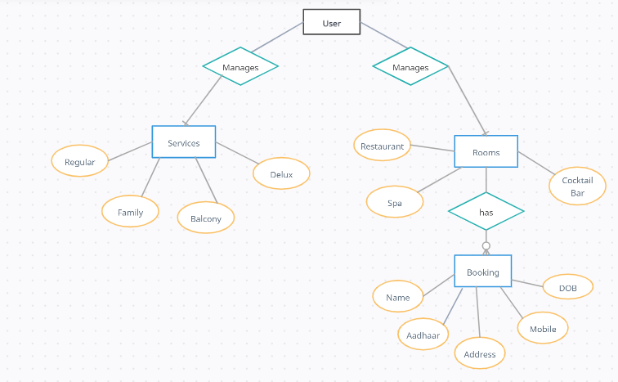

**3.2 CONTEXT LEVEL DIAGRAM**

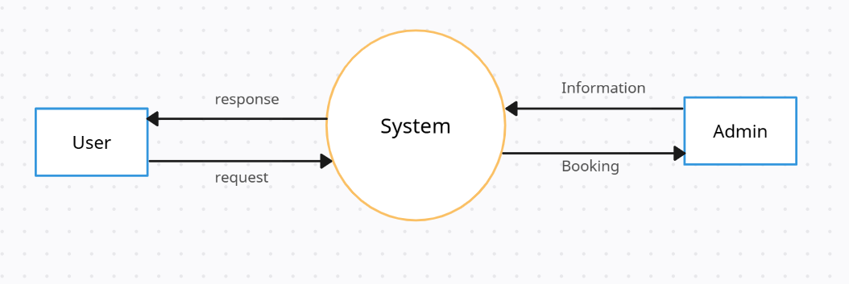

**3.3 DATA FLOW DIAGRAM**

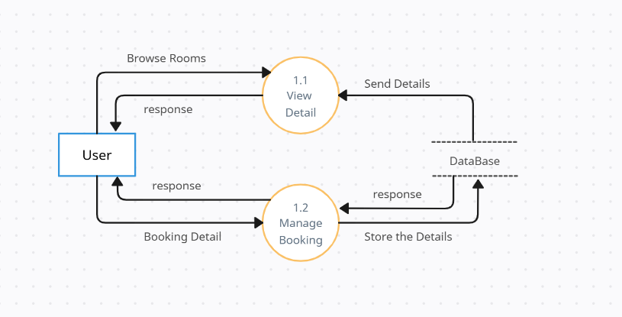

**3.4 FILE DESIGNING**

|  |  |  |  |
| --- | --- | --- | --- |
| **Field Name** | **Data Type** | **Size** | **Description** |
| customer_id | INT | 10 | Unique identifier for each customer (Primary Key) |
| name | VARCHAR | 100 | Full name of the customer |
| contact_no | VARCHAR | 15 | Customer’s contact number |
| email | VARCHAR | 100 | Customer’s email address |
| address | TEXT | - | Residential address of the customer |
| aadhaar_no | VARCHAR | 12 | 12-digit Aadhaar number (Unique ID) |

|  |  |  |  |
| --- | --- | --- | --- |
| booking_id | INT | 10 | Unique booking ID (Primary Key) |
| customer_id | INT | 10 | Customer ID (Foreign Key) |
| room_type | VARCHAR | 50 | Type of room booked (Deluxe, Family, Regular, etc.) |
| booking_date | DATE | - | Date of booking |
| check_in_date | DATE | - | Check-in date for the room |
| check_out_date | DATE | - | Check-out date for the room |
| total_price | DECIMAL | 10,2 | Total amount for the booking |
| room_id | INT | 10 | Unique identifier for each room (Primary Key) |
| room_type | VARCHAR | 50 | Type of room (Deluxe, Family, Regular, etc.) |
| price_per_night | DECIMAL | 10,2 | Price per night for the room |
| availability | BOOLEAN | 1 | Indicates if the room is available (1: Available, 0: Booked) |

|  |  |  |  |
| --- | --- | --- | --- |
| service_id | INT | 10 | Unique identifier for each service (Primary Key) |
| service_name | VARCHAR | 100 | Name of the service (WiFi, Spa, Gym, etc.) |
| description | TEXT | - | Description of the service provided |
| price | DECIMAL | 10,2 | Cost of the service (if applicable) |

**3.5 DATA DICTIONARY**

|  |  |  |  |
| --- | --- | --- | --- |
| **Field Name** | **Data Type** | **Size** | **Description** |
| address | TEXT | - | Residential address of the customer |
| aadhaar_no | VARCHAR | 12 | 12-digit Aadhaar number (Unique ID) |
| availability | BOOLEAN | 1 | Indicates if the room is available (1: Available, 0: Booked) |
| booking_date | DATE | - | Date of booking |
| booking_id | INT | 10 | Unique booking ID (Primary Key) |
| check_in_date | DATE | - | Check-in date for the room |
| check_out_date | DATE | - | Check-out date for the room |
| contact_no | VARCHAR | 15 | Customer’s contact number |
| customer_id | INT | 10 | Unique identifier for each customer (Primary Key) |
| email | VARCHAR | 100 | Customer’s email address |
| name | VARCHAR | 100 | Full name of the customer |
| price_per_night | DECIMAL | 10,2 | Price per night for the room |
| room_id | INT | 10 | Unique identifier for each room |
| room_type | VARCHAR | 50 | Type of room booked (Deluxe, Family, Regular, etc.) |
| service_description | TEXT | - | Description of the service provided |
| service_id | INT | 10 | Unique identifier for each service |
| service_name | VARCHAR | 100 | Name of the service (WiFi, Spa, Gym, etc.) |
| service_price | DECIMAL | 10,2 | Cost of the service (if applicable) |
| total_price | DECIMAL | 10,2 | Total amount for the booking |

**4. FORM DISGNING**

**Home page**

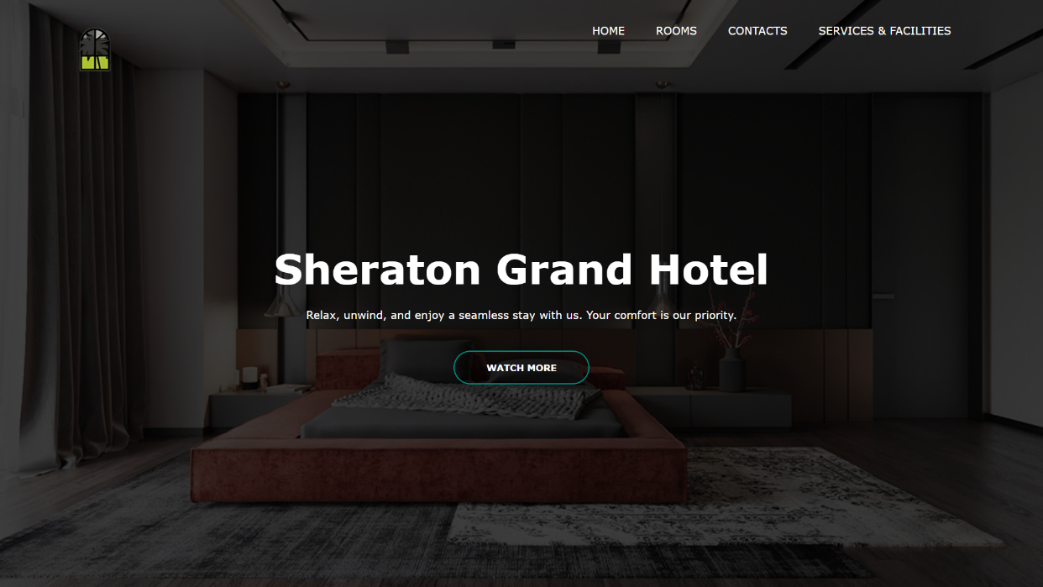

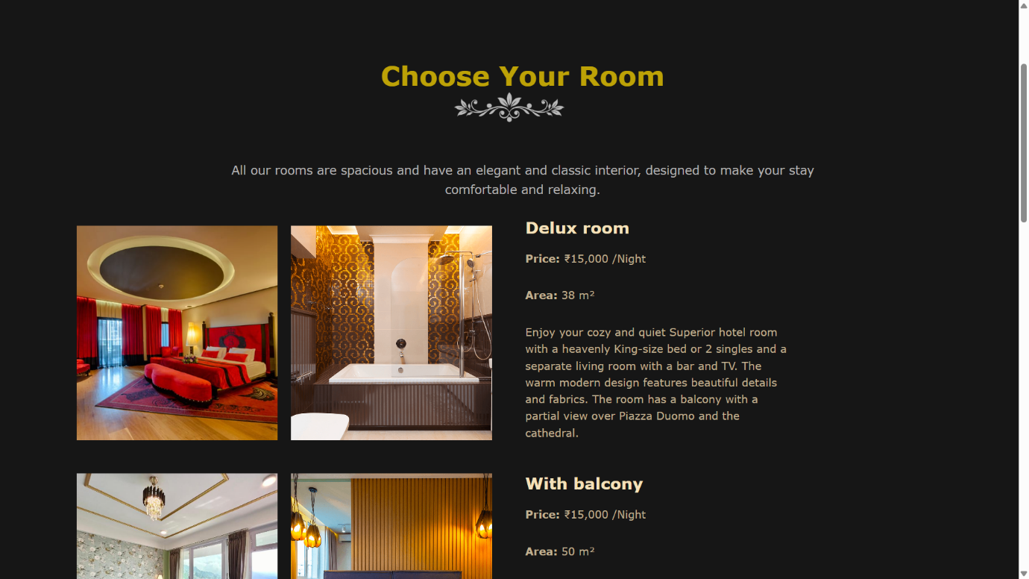 Room page

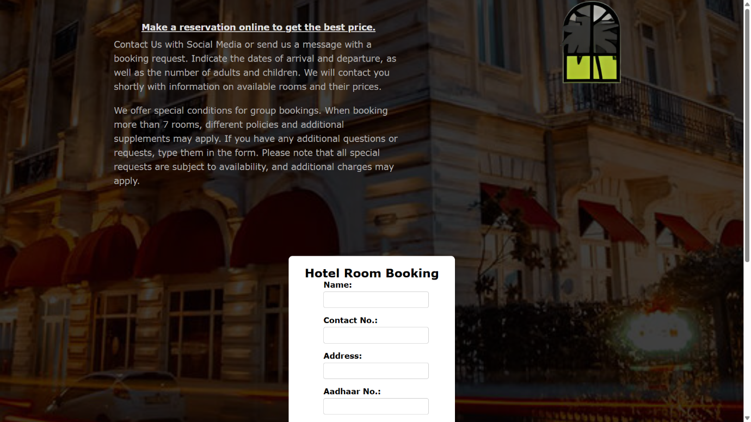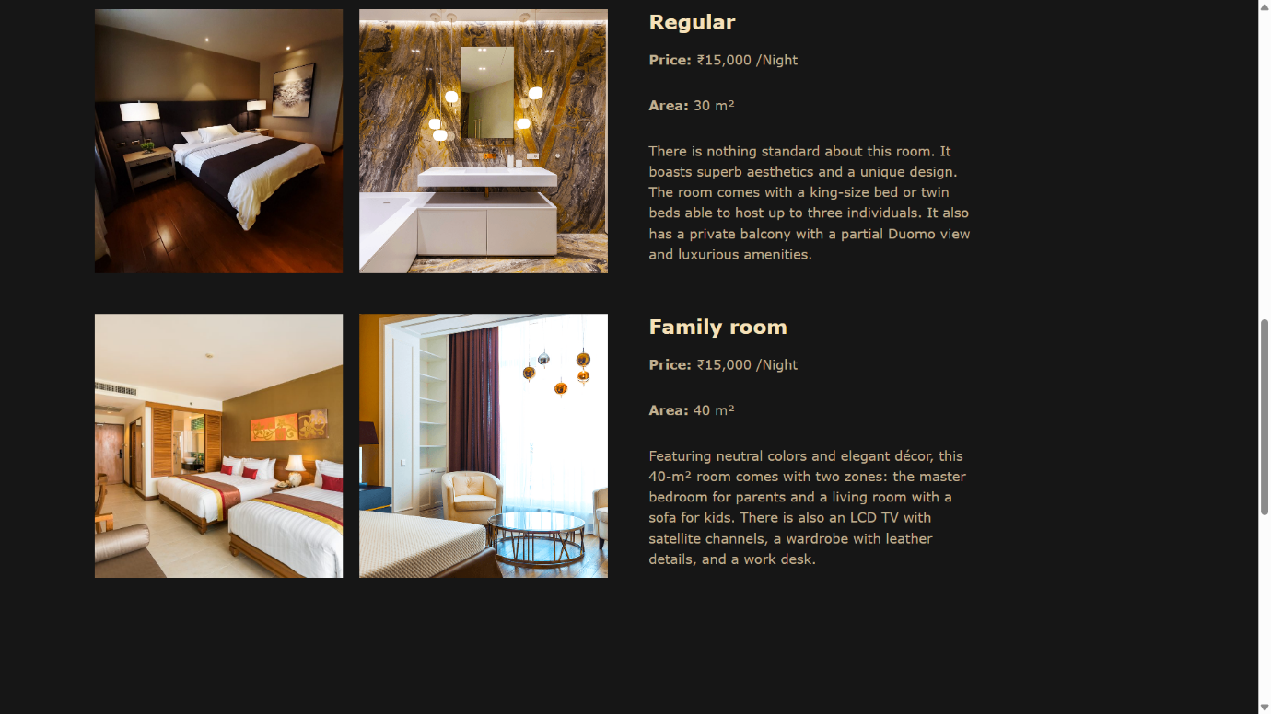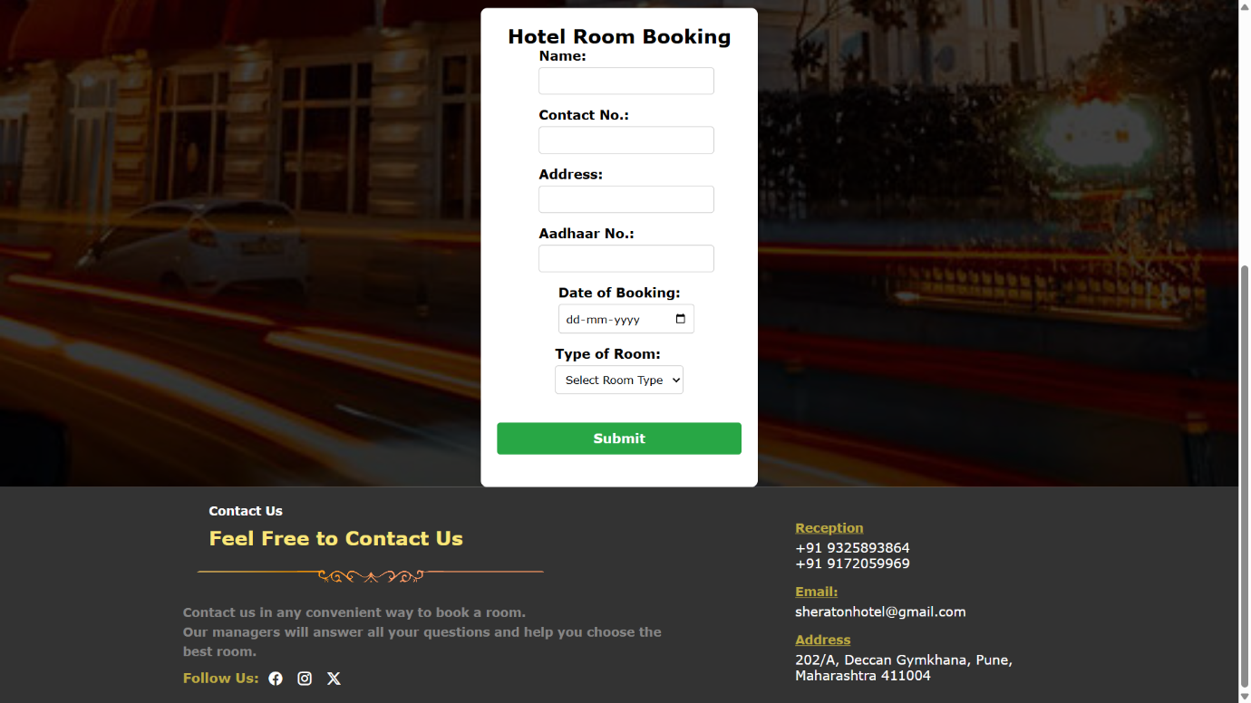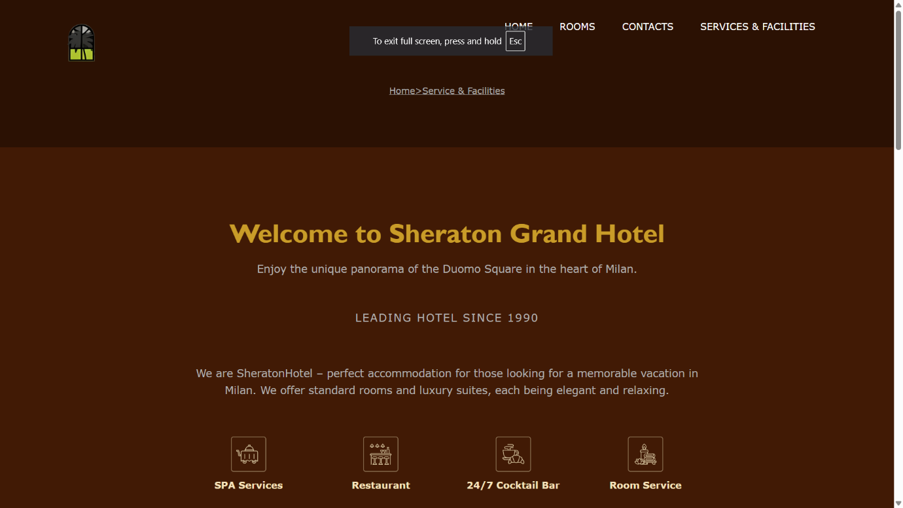**SEVERCES AND FACILITIES PAGE**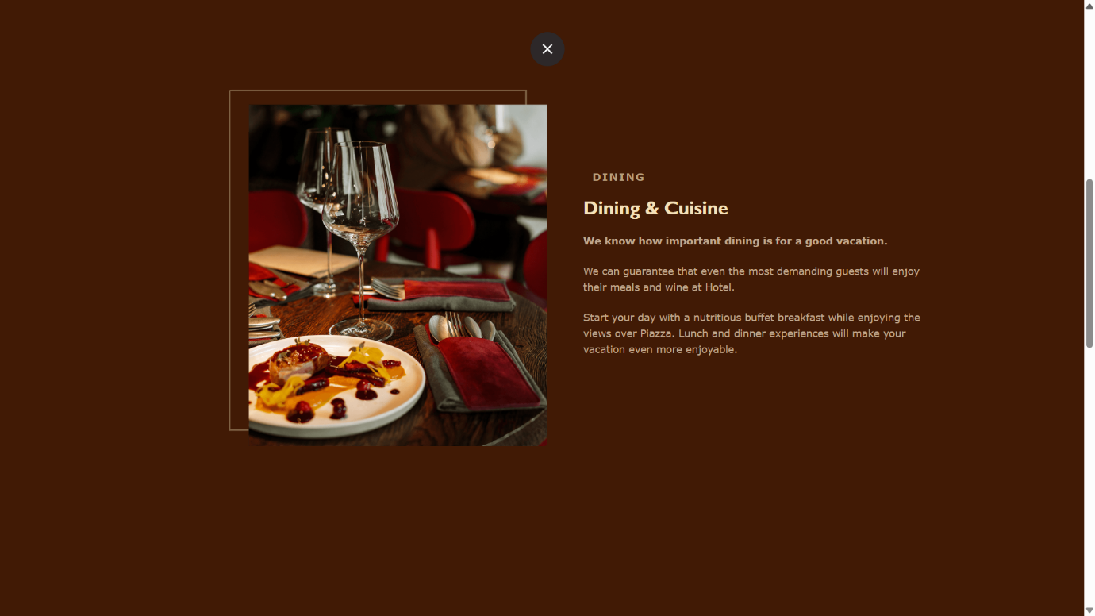

**CONTACT PAGE AND BOOKING**

1. **REPORTS**

**Sheraton Grand Hotel Website Development Report**

**1. Introduction**

This report outlines the development of the **Sheraton Grand Hotel Website**, designed to provide a **user-friendly online platform** for guests to explore hotel accommodations, book rooms, and access services. The website aims to enhance customer experience, streamline operations, and boost the hotel's online presence.

**2. Objectives**

* Provide an **informative and visually appealing** platform.
* Allow guests to **view rooms, pricing, and features** easily.
* Implement a **seamless room booking system**.
* Showcase the hotel’s **services and facilities**.
* Ensure **security, responsiveness, and smooth navigation**.

**3. Scope of the Website**

* **Home Page** – Brief introduction to the hotel.
* **Rooms Page** – Displays images, prices, and features of rooms.
* **Booking Page** – Online form for reservations (Name, Email, Aadhaar No., Address, Booking Date, Room Type).
* **Services & Facilities Page** – Lists hotel amenities like dining, spa, pool, and event spaces.

**4. Feasibility Study**

* **Technical Feasibility** – Built with **modern web technologies** (HTML, CSS, JavaScript, PHP, MySQL).
* **Economic Feasibility** – Cost-effective investment that enhances revenue through **online bookings**.
* **Operational Feasibility** – Reduces manual workload and improves **guest satisfaction**.
* **Legal Feasibility** – Ensures **data privacy and Aadhaar verification compliance**.
* **Schedule Feasibility** – Development is estimated to take **3-6 months**.

**5. Fact-Finding Techniques**

* **Interviews** – Discussions with hotel management and staff.
* **Surveys** – Gathering customer feedback.
* **Observation** – Studying hotel operations and guest interactions.
* **Document Review** – Analyzing hotel brochures and competitor websites.
* **Prototyping** – Testing wireframes and improving based on feedback.

**6. Hardware & Software Requirements**

**Hardware:**

* **Web Server** – Cloud-based hosting (AWS, Bluehost).
* **Storage** – Minimum **100GB SSD storage**.
* **RAM & Processor** – 8GB RAM, Intel Core i5 or higher.
* **Backup System** – Cloud-based data backup solutions.

**Software:**

* **Development Tools** – Visual Studio Code, MySQL, PHP, React.js.
* **Hosting & Security** – SSL certificate, Cloudflare firewall.
* **Analytics & SEO Tools** – Google Analytics, SEO plugins.

**7. Expected Outcomes**

* A **fully functional, responsive, and user-friendly website**.
* Increased **guest engagement and online bookings**.
* Enhanced **brand visibility and customer satisfaction**.
* Secure and **efficient handling of guest data**.

1. **LIMITATIONS**

**Limitations of Sheraton Grand Hotel Website**

While the **Sheraton Grand Hotel Website** is designed to enhance user experience and streamline hotel operations, it has some limitations:

1. **Limited Online Payment Integration**
   * Initially, the website does not support **online payments**, requiring manual confirmation for bookings.
2. **Dependence on Internet Connectivity**
   * Users need a **stable internet connection** to access and use the website effectively.
3. **Security Risks**
   * **Personal data (Aadhaar, email, address)** must be securely handled to prevent unauthorized access and data breaches.

**7. ADVANTAGES AND DISADVANTAGES**

**Advantages and Disadvantages of Sheraton Grand Hotel Website**

**Advantages:**

1. **Convenient Online Booking** – Customers can book rooms anytime, reducing the need for phone or in-person reservations.
2. **Enhanced User Experience** – A well-designed interface makes it easy for users to explore rooms, services, and facilities.
3. **24/7 Availability** – Guests can access information and make bookings at any time, unlike traditional booking methods.

**Disadvantages:**

1. **Technical Issues** – Website downtime, server failures, or bugs can affect the booking process.
2. **Security Risks** – Handling sensitive user data (Aadhaar, email, address) requires strict security measures.

**8. FUTURE ENHANCEMENTS**

• Online Payment Integration

* Implement secure payment gateways (PayPal, Razorpay, Stripe) to allow instant payments during booking.

• Customer Reviews and Ratings

* Allow guests to leave reviews and ratings for rooms and services to build trust.

• Mobile App Development

* Develop a dedicated mobile application for an improved user experience on smartphones.

**9. Bibliography**

1. **Books & Research Papers:**
   * “Web Development with HTML, CSS, and JavaScript” – Jon Duckett
   * “E-Commerce and Hospitality Management” – Wiley Publications
2. **Web Sources:**
   * Official hotel websites (e.g., **Marriott, Hilton, Taj**) for industry best practices.
   * **W3Schools & MDN Web Docs** for technical references.
   * **Google Analytics & SEO blogs** for digital marketing insights.
3. **Interviews & Surveys:**
   * Discussions with **hotel management, staff, and guests** for feedback.
   * Market research on **customer booking preferences and digital trends**.